SKILL WEEK-9
SESSION-17
Task-1: To Implement how to List Active Jobs, Display Status Information, Retrieve Job [Ds, Format Output, Update State Information, Test Job Listings].
Source code:
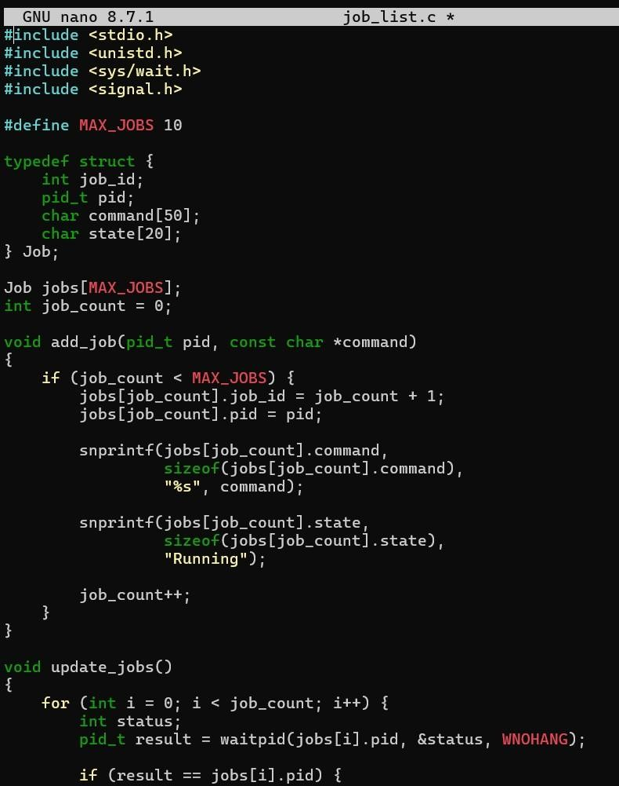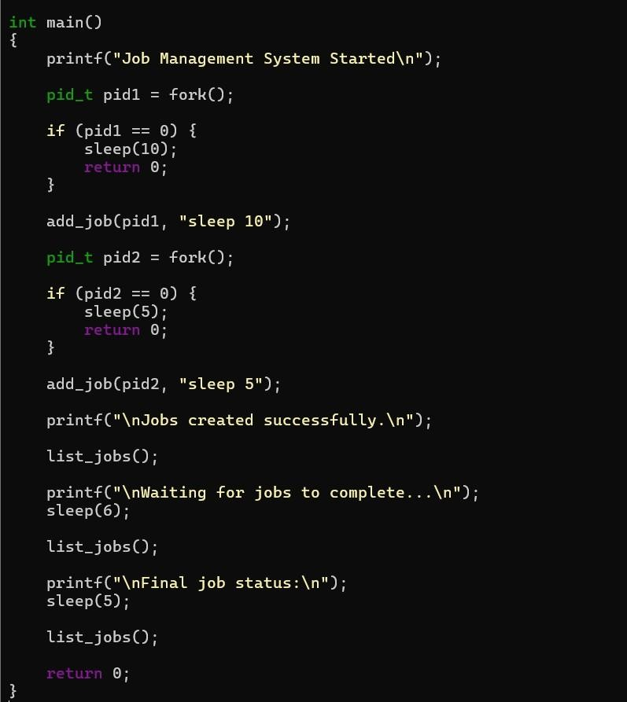
Output:
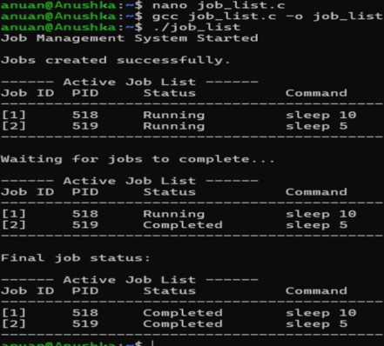
Observation:
Initially, both jobs are displayed as Running. After the sleep 5 process finishes, its state changes to Completed. After the remaining process finishes, both jobs are shown as Completed.
Task-2: To design how to Identify Target Job, Transfer Terminal Control, Resume Processes, Wait for Completion, Update Job State, Test Foreground Switching.
Source code:
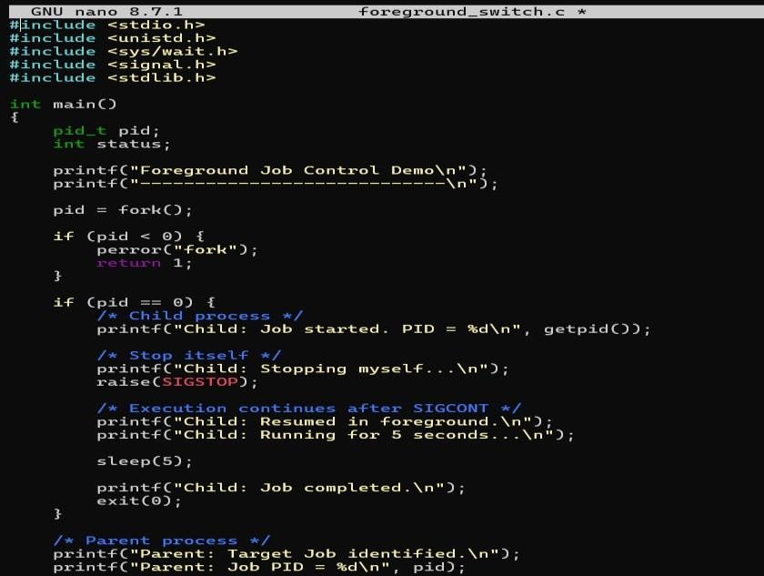
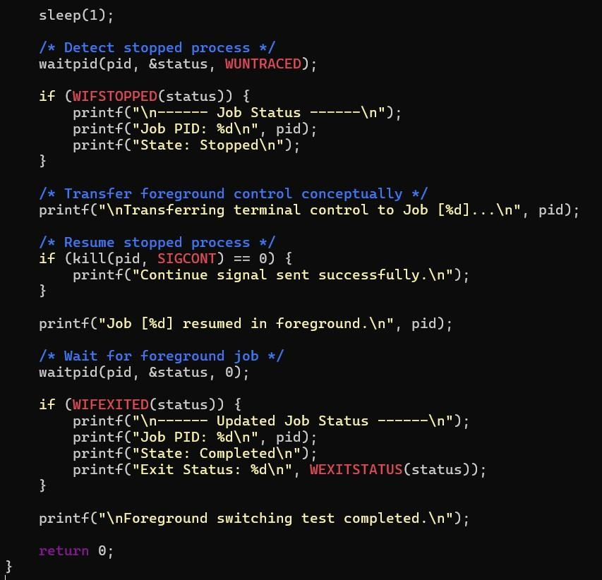
Output:
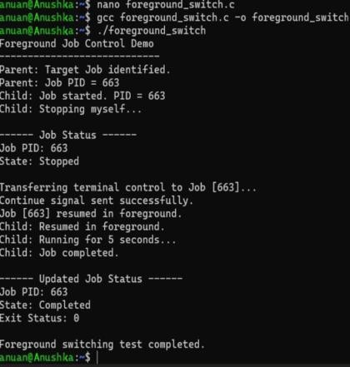

Observation:
The child process initially enters the Stopped state. The parent identifies the target job and sends SIGCONT. The process resumes, executes in the foreground, and after completion its state is updated to Completed.
SESSION-18
Task-1: To Analyze Signal Delivery, Understand Signal Masks, Review Process Groups, Explore Terminal Signals, Test Signal Behavior.
Source code:
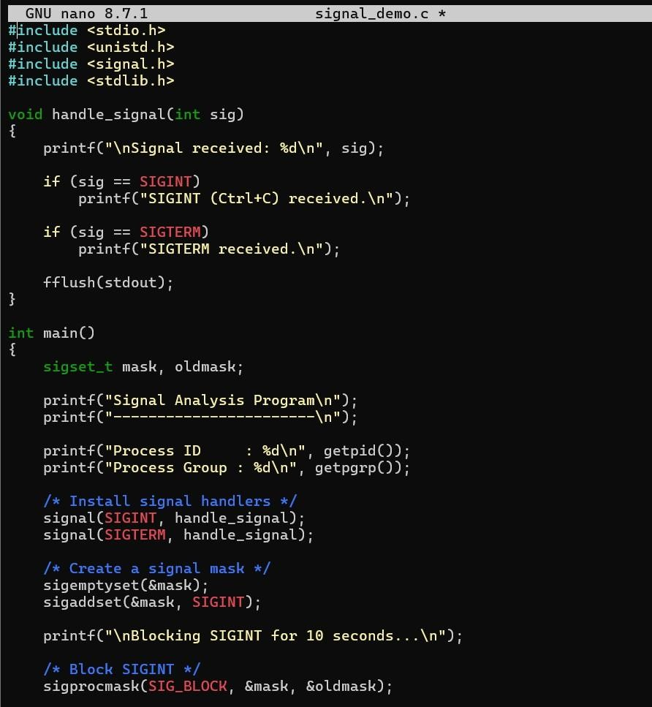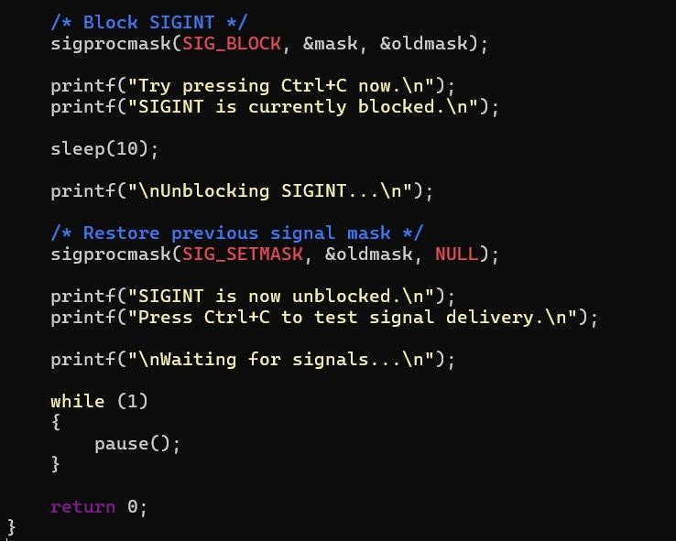

Output:
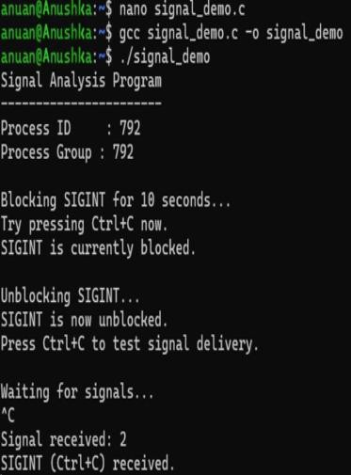
Observation:
The experiment successfully demonstrates signal delivery, signal masking, process groups, terminal-generated signals, and signal behavior in Linux. It also shows how these mechanisms are fundamental to implementing foreground and background job control in a shell.
Task-2: To implement how to resume Stopped Jobs, Send Continue Signals, Update Job Status, Maintain Job Table, Verifr Execution, Test Background Recovery.
Source code:
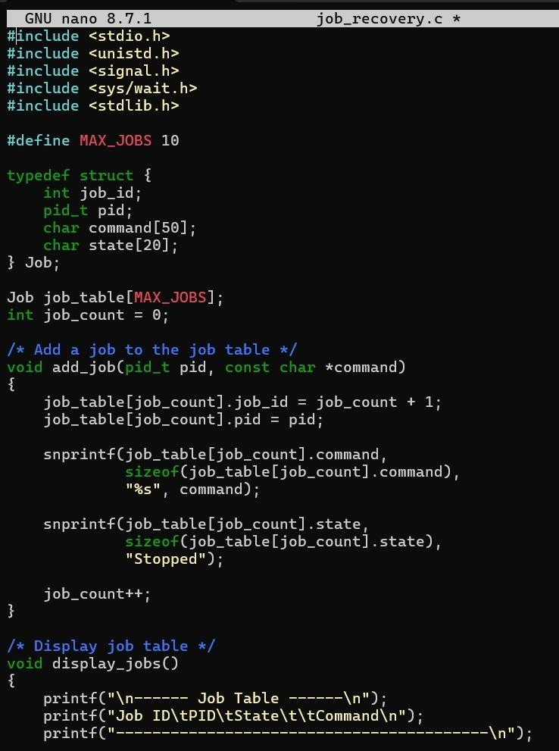
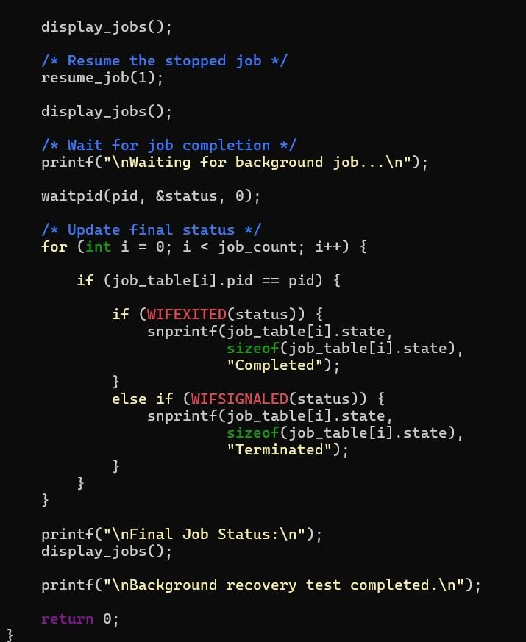
Output:
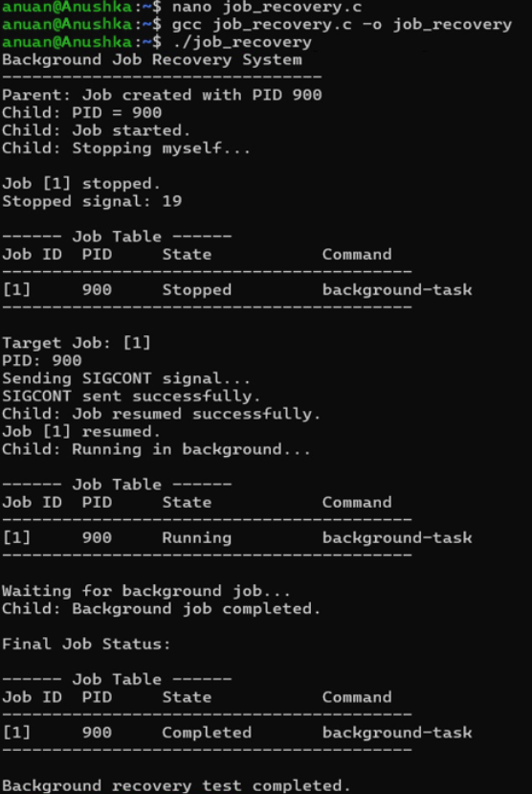
Observation:
The stopped job is successfully detected and stored in the job table. The SIGCONT signal resumes the process, and its state changes from Stopped → Running → Completed after successful execution.

